Project Management 8
ASSIGNMENT 8.1

1.When to use (Rapid Application Development) RAD model When not to use (Rapid Application Development) RAD model

1. Answer:
When to use:
- For low budges projects for which automated code generation cost is low.
- When high skilled resources are available.
- When it’s easy to modularize the project.
- If technical risks are low.
- If development needed to complete in specified time.
- RAD Model is suitable if the functionality have less dependencies on other functionality.
RAD is best used when we are developing something which is basically being built upon the foundations of an existing prototype. The reason being the re-use of prototypes which reduces both the process of software development and the testing time required.

When not to use:
RAD works well only if high skilled engineers are available and the customer is also committed to achieve the targeted prototype in the given time frame. If there is commitment lacking on either side the model may fail
Also it should not be used for new cutting edge functionality which has not been developed before as this usually consist of completely new functionality requirements RAD simply wouldn’t work.

Advantages of the RAD model:
- Reduced development time.
- Increases reusability of components
- Quick initial reviews occur
- Encourages customer feedback
- Integration from very beginning solves a lot of integration issues.
Disadvantages of RAD model:
- Depends on strong team and individual performances for identifying business requirements.
- Only system that can be modularized can be built using RAD
- Requires highly skilled developers/designers.
- High dependency on modeling skills
- Inapplicable to cheaper projects as cost of modeling and automated code generation is very high.

2.Define an ER diagram of a software Organization with all the relationship model that was discussed in the classroom

2. Answer:
Age
Dept_ ID
Name
Salary
Name
DOB

contact
Works for
E_Id
Employees
Department

Sex

Works on
Project
control

Name
P_Number

3.Describe the Entity Relationships

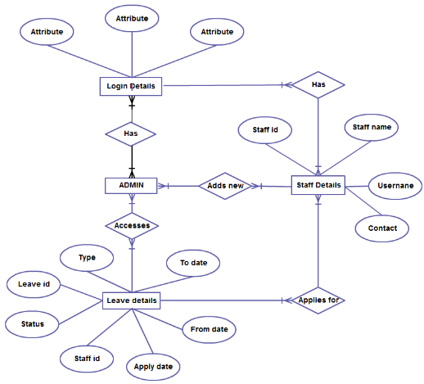

3. Answer:
In the given er diagram
entities iclude -
- Login details
- Admin
- staff details
- leave details

Relationship -
- Has
- Adds new
- applies for
- accesses
Atributes -
- staff id
- staff name
- user name
- contact
- to date
- from date
- apply date
- staff id
- status
- leave id
- type

Relationship of the entity staff
- Staff id is the primary key.
- Many staff has differnt login that is many to many relation.
- Many staff applies for many leaves that is many to many relation.
- Staff details has staff name,user name,contacts,staff id.

Admin
- Admins can add new staffs. Many to many relation.
- Leave deatils can be accessed by Admin and is many to many relation.
- Admin has relationship with Login deatils.
- Admin can know the type of leave

Leave details
- Leave deatils has the following attributes type,leave id,status,staff id,apply date,from date,to date.
- Leave id primary key here
- The foreign key staff id used in this entity.

